CO-03
2016 IE Strategy Memorandum

Updated on 5/17/16
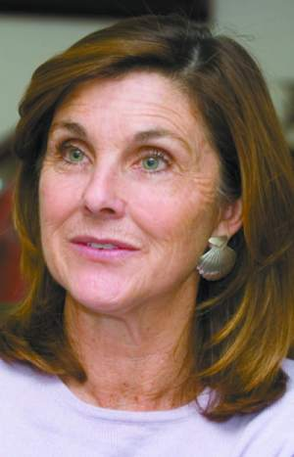
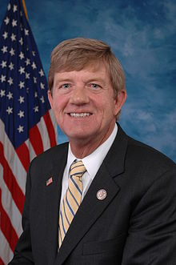

GAIL SCHWARTZ SCOTT TIPTON
CoH: $ --- CoH: $604,947.25
Date: 4/15/16 Date: 4/15/16
Occupation: Colorado State Senator Occupation: Congressman

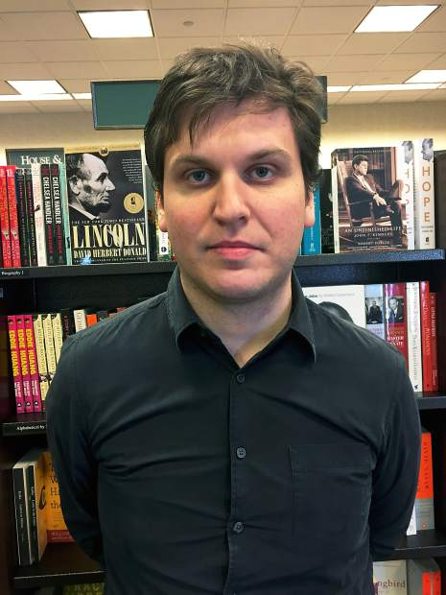

ALEX BEINSTEIN
CoH: -
Date: 4/15/2016
Occupation: Lawyer

SECTION I: Race Overview
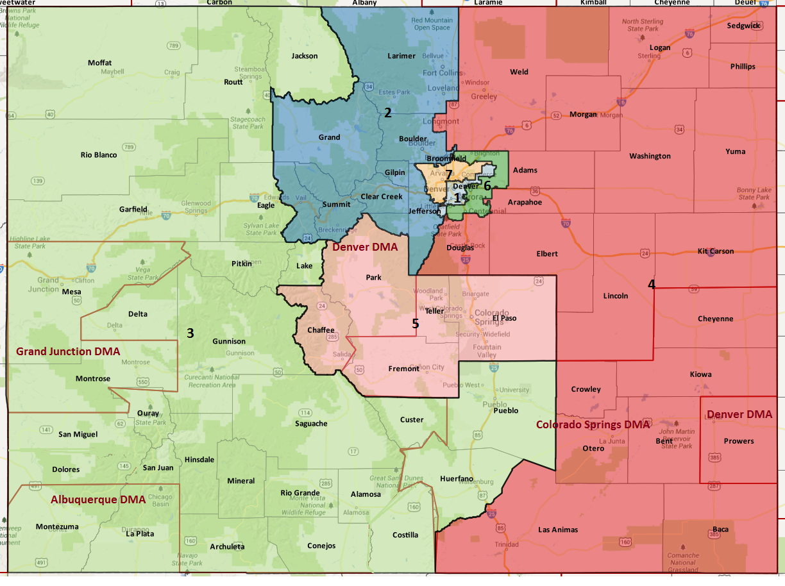

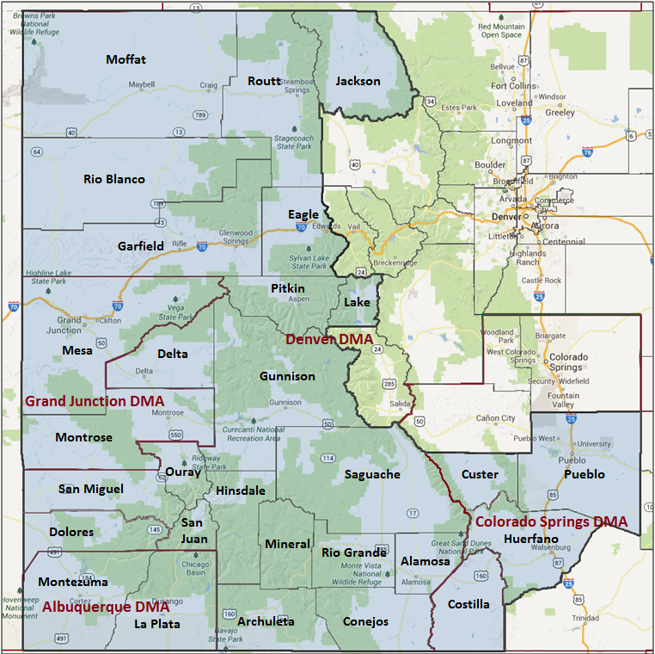

Media Market Costs

TV DMA | % of  CD | I.E.  35+ CPP | Cable CPP
DENVER | 39% | $850 | $242
ALBUQUERQUE | 12% | $189 | $72
GRAND JUNTION | 25% | $68 | $101
COLORADO SPRINGS | 24% | $140 | $151
C0-03 TOTALS: | 100.0%
Radio Landscape
DMA | Universe | CPP
Grand Junction | 89,000 | $27

Presidential Statistics
Cycle | Candidate | Party | Vote
2012 | Obama | DEM | 46.9%
2012 | Romney | REP | 53.1%
2008 | Obama | DEM | 49.3%
2008 | McCain | REP | 50.7%

Congressional Statistics
Cycle | W/L | Candidate | Party | Vote
2014 | L | TAPIA | DEM | 38.1%
2014 | W | TIPTON | REP | 61.9%
2012 | L | PACE | DEM | 43.6%
2012 | W | TIPTON | REP | 56.4%

NCEC Data
Dem Performance: 46.9%
BVAP: 1 %
Hispanic: 17.5%
Asian: .8%
Total Minority: 19.3%

Critical Dates
Filing Date: March 1st, 2016
Primary Date: June 28th, 2016

Summary of 2014 Cycle Spending by Outside Groups

None

Summary of 2012 Cycle Spending by Outside Groups

TV Competitive Summary -- Denver
Campaign/Group | GRPs | Total Dollars
Pace/DCCC | 18 | $11,004
DCCC | 830 | $405,956
Good Guys v Bad Guys | Total GRPs | Total Dollars
Good Guys | 848 | $416,960
Bad Guys | 0 | $0
TV Competitive Summary -- Colorado Springs
Campaign/Group | GRPs | Total Dollars
Pace/DCCC | 654 | $59,705
Tipton/NRCC | 682 | $40,930
ATR | 2490 | $880,458
Good Guys v Bad Guys | Total GRPs | Total Dollars
Good Guys | 654 | $59,705
Bad Guys | 3,172 | $921,388
TV Competitive Summary -- Grand Junction
Campaign/Group | GRPs | Total Dollars
Pace/DCCC | 480 | $20,035
Tipton/NRCC | 674 | $16,845
ATR | 2209 | $382,783
Good Guys v Bad Guys | Total GRPs | Total Dollars
Good Guys | 480 | $20,035
Bad Guys | 2,883 | $399,628
TV Competitive Summary -- Albuquerque
Campaign/Group | GRPs | Total Dollars
Pace/DCCC | 111 | $11,688
Good Guys v Bad Guys | Total GRPs | Total Dollars
Good Guys | 111 | $11,688
Bad Guys | 0 | $0
Pre-Election Day Voting

Type of  “Early Voting” | Start Date  End Date | Percent of  Vote Cast Using this Method | Brief Description  (where/how  do people vote) | Timeframe (when does the majority of voting happen)
Vote By Mail | Oct. – 17th Nov. 8th 7:00 | 60% | 100% VBM state. Can be mailed or dropped off at clerk’s office by 7:00 on election day.

SECTION II: DISTRICT OVERVIEW

- District Overview and Data

  - Political Landscape
- Scott Tipton has proven to be a difficult candidate to crack after surviving a first term presidential year with weak fundraising and potential ethics issues. He defeated Sal Pace, a candidate with his own weaknesses, handedly 56-43 in 2012. The 2012 IE played in this race to keep parody between Tipton and Pace.
- The multiple media markets in this district further complicate the race.
- Colorado State Senator Gail Schwartz was nominated to the Democratic Party ticket at the convention in April 2016. Her bio and message fit the district and has run disciplined, on message campaigns in the past for her State Senate races. She has the potential to contribute some money to her campaign as well, but not entirely self-fund.
- Colorado’s vote by mail laws changed in 2013, now all registered voters receive a mail-in ballot. Voters may still cast ballots in person on Election Day. The state also allows for same day voter registration.

  - District Demographics
- Colorado's 3rd congressional district is located in western and south central Colorado, encompassing most of the rural Western Slope. It includes the cities of Grand Junction and Durango as well as southern portions of Colorado's eastern plains, including the city of Pueblo.
- The district has two major population centers in Grand Junction and Pueblo. The two cities and their surrounding rural areas provide a competitive arena for congressional races. Grand Junction, on the Western Slope, provides a base for conservatism while Pueblo, a town with a large Latino population and (by Colorado norms) a heavily unionized workforce, provides a base of support for Democrats

- The economy is largely agriculture based with lots of farmers and ranchers, but the tourism and service industries also have huge footprints.

District Demographics

- Cook Partisan Voting Index: R+5
- Urban Population: 2.5%
- Rural Population: 59.6%
- Suburb Population: 37.9%
- Median Income: $49,885
- Poverty Status: 9.6%
- Military Veterans: 11.7%
- Race/Ethnic Origin: 80.7% White; 1% Black; .8% Asian; 17.5% Hispanic

  - Electoral Context
- Colorado will be home to highly competitive Presidential and Senate campaigns (Bennett) that are going to drive the avg CPP up and crowd the airwaves.
- Three potential ballot initiatives may also be factors in 2016. One major measure would replace the current healthcare exchange with a single payer healthcare plan, paid for by a 10% premium tax on payroll or other income. A second initiative allows cities and counties to ban fracking, a contentious issue in the energy and environmental communities in Colorado. A final potential measure would allow for the sales of full strength liquor in grocery stores.
- Senate and Presidential campaigns will focus on Albuquerque and Durango for turnout.

  - Press Presence
- Pueblo Chieftain – drives coverage in Pueblo market
Denver Post - paper of record; very friendly
Daily Sentinel- drives coverage in Grand Junction
Durango Herald – drives coverage in SW “four corners” area
Aspen Times, Colorado Independent, and Valley Courier also will all cover the race closely
Colorado Peak Politics is a conservative website that tends to leak out all the Tipton talking points.

CO-03 Research

Scott Tipton (Republican Incumbent) Vulnerabilities

Scott Tipton was elected to Congress in 2010 after defeating John Salazar. Prior to that he had served in the Colorado House of Representatives since 2008 and had a small pottery business for several decades.

An update to the Tipton book is currently underway and should be complete in the next four weeks.

Top Hits
- Voted for plan that resulted in the government shutdown in 2013 and then blocked vote to reopen government
- Voted to oppose DAPA/DACA relief
- Voted against consideration of paycheck fairness bill
- Voted to repeal Obamacare and Planned Parenthood
- Multiple ethics issues—his office used vendors that did business with his nephew’s company, Broadnet (a company that sets up telephone town hall meetings for legislators and constituents) and then he apologized to the Ethics committee after it came to light that his daughter used his name to try to secure contracts from Congressional offices for the same company in 2011
- Also used official office money for campaign purposes in 2012
- Opposed permanent protection the Thompson Divide
- Voted against the Highway Funding Bill
- Voted against reauthorizing the Export-Import Bank

Gail Schwartz (Democratic Challenger) Vulnerabilities

Gail Schwartz has been a state Senator since 2006 and prior to that served on the Colorado Commission on Higher Education and the University Of Colorado Board Of Regents.

- Voted to increase tuition at the University of Colorado
- Voted to increase pay for rural Colorado lawmakers
- Voted to allow people with concealed carry permits to skip background checks

SECTION III: Appendix

- 2016 Campaign Side Consulting Team
Media:
Mail:
Polling:
Online/Digital:
Self-research:

